Skudonet Issue.

As you can see, I added the lines you told me, and I have realized that the info is updating automatically

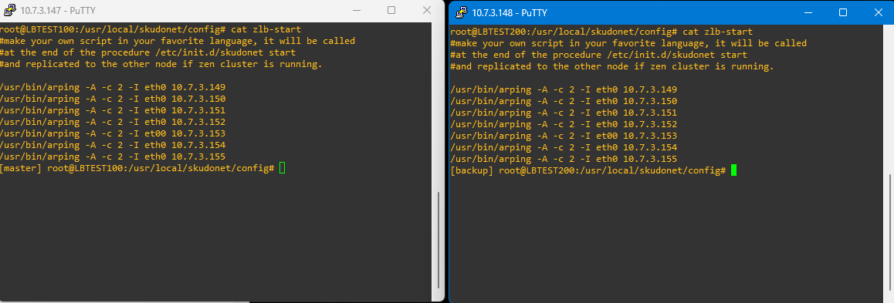

Right now, the node 1 is the master:

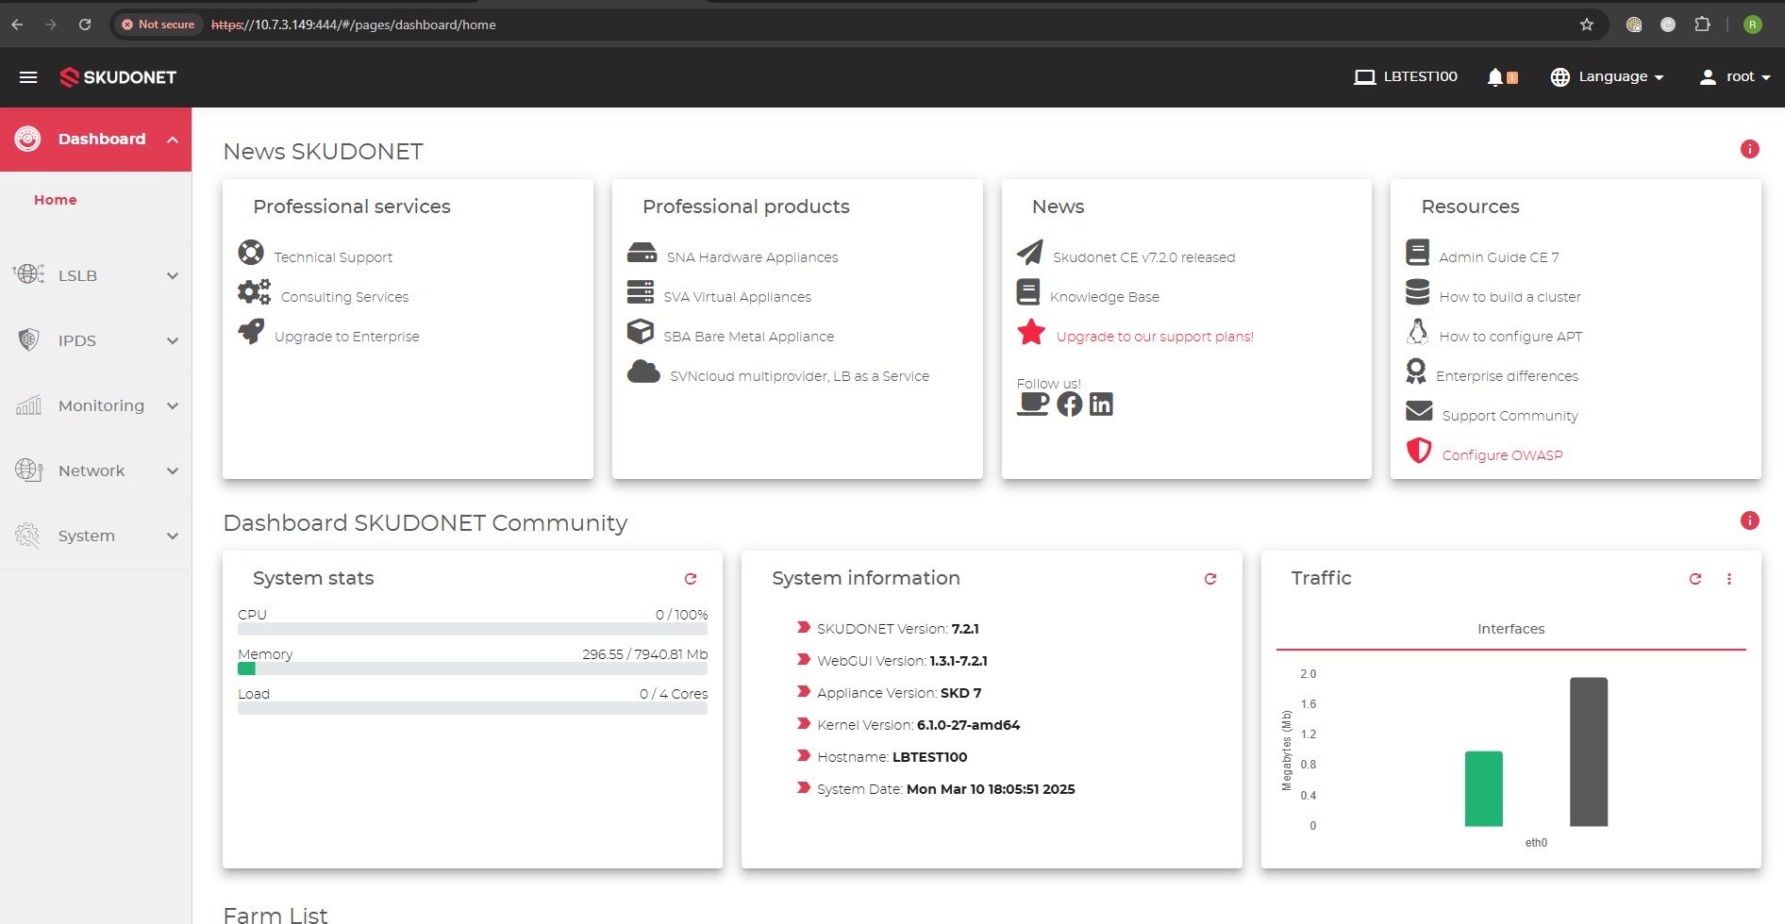

When we made Failover to node 2 it kept doing the same thing.
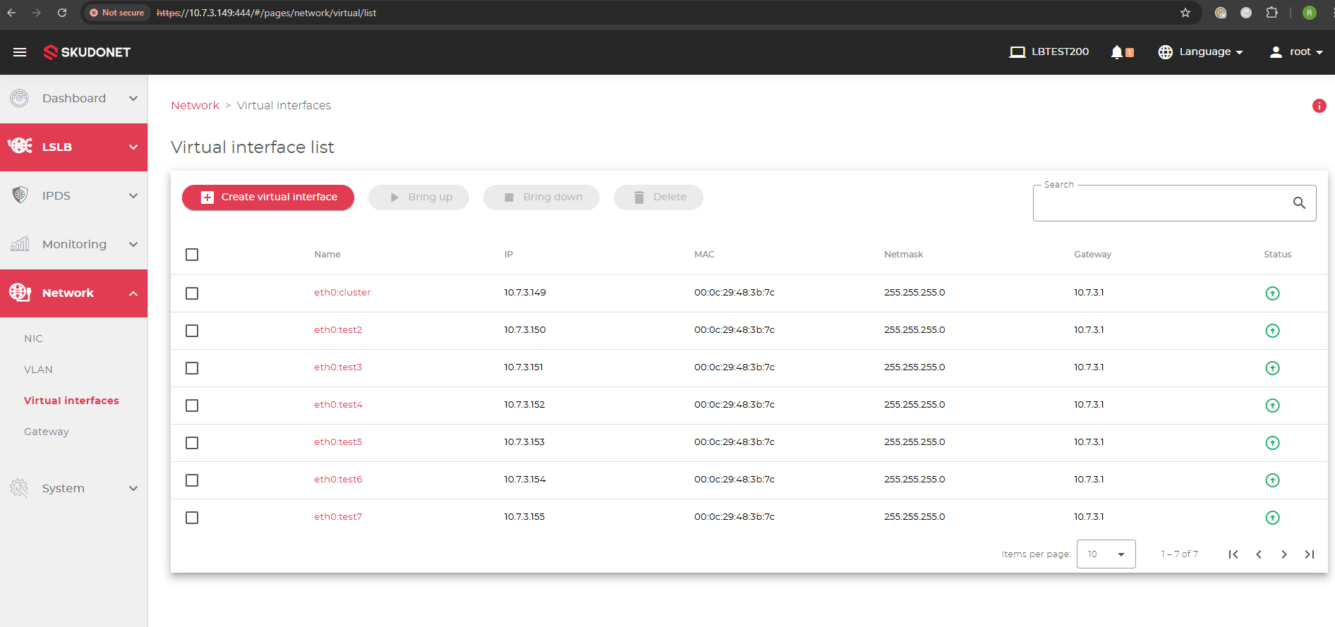
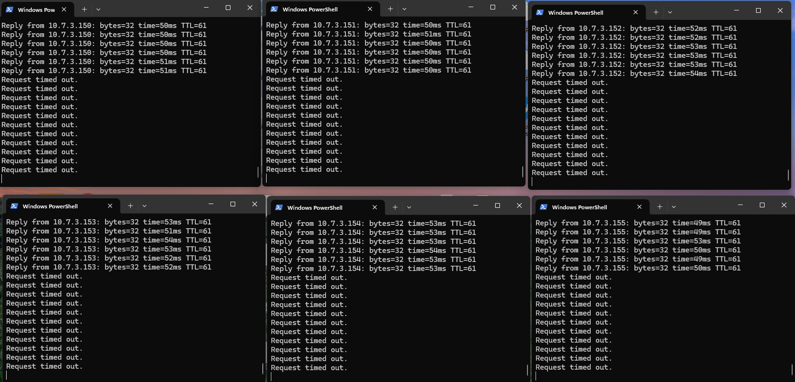

And here’s one of the commands you sent me:

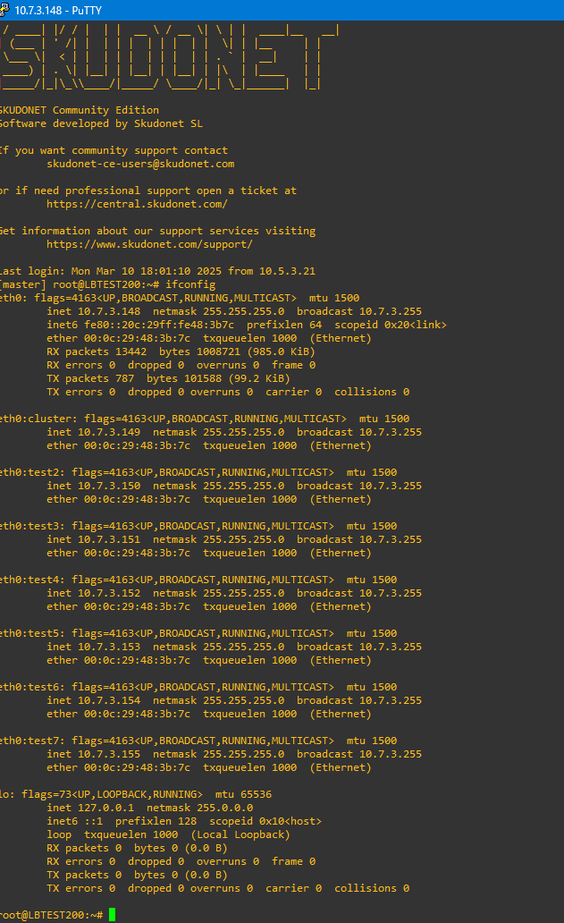
Since I didn’t create any farm, I don’t think it was necessary to run the other commands.

